To begin open the Arduino IDE programming environment and go to settings

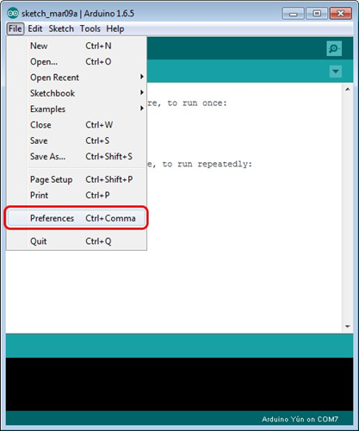

Then in the window that appears in the row Additional Boards Manager URLs (marked in red) insert <http://arduino.esp8266.com/stable/package_esp8266com_index.json> link for installation in Arduino IDE additional scripts that would work with the modules ESP8266, and click OK

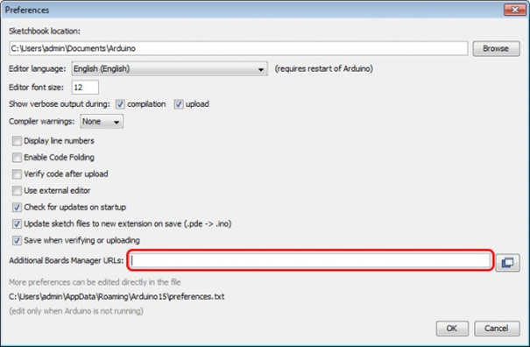

Then go to the Tools> Board> Boards Manager

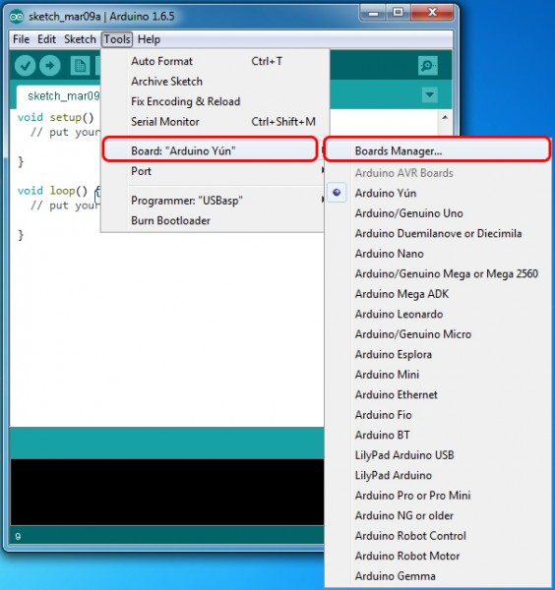

In the window that appears, scroll through the list down to the script esp8266 by ESP8266 Community and click.

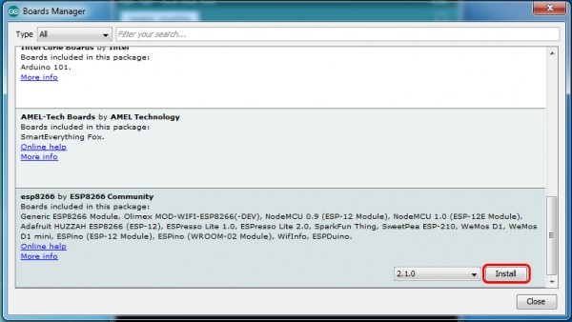

In the lower right corner will be able to select the version of the software, select the version 2.1.0 (the newest) and click the Install button

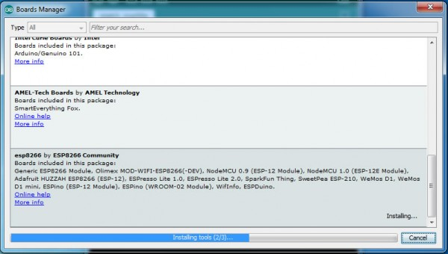

After installation, close the window and go to Tools> Board and see the list of available devices on the chip programming ESP8266

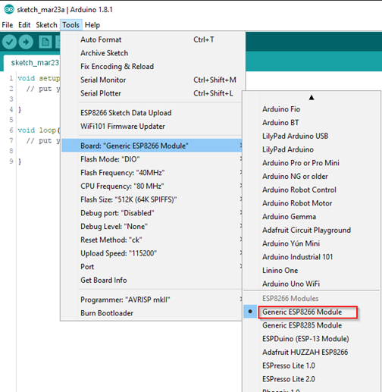

Next, you need to select the card as shown in the picture (Generic ESP8266 module)

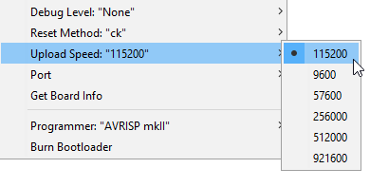

Select the upload speed - 115200

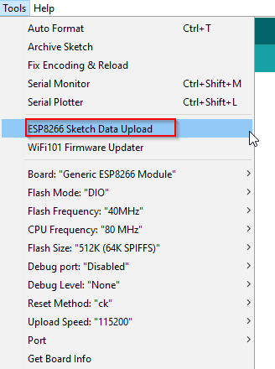

==========test sketch===========

void setup()

{ Serial.begin(115200);

pinMode(14,OUTPUT);

delay(500);

Serial.println("AT+CIPMUX=1");

delay(2000);

Serial.println("AT+CIPSERVER=1,5000");

delay(2000);

Serial.println("AT+CIPSTO=3600");

delay(2000); }

void loop()

{ while(Serial.available())

{ char Rdata;

Rdata=Serial.read();

if(Rdata=='A'|Rdata=='a')

{ digitalWrite(14,HIGH);

delay(50); }

else if(Rdata=='B'|Rdata=='b')

{ digitalWrite(14,LOW);

delay(10);

digitalWrite(14,HIGH);

delay(10);

digitalWrite(14,LOW); }

else

{ digitalWrite(14,LOW); } } }